Data Structures

Lecture No. 36

Reading Material
Data Structures and Algorithm Analysis in C++ Chapter. 8
8.4, 8.5, 8.6

Summary
- Running Time Analysis
- Union by Size
- Analysis of Union by Size
- Union by Height
- Sprucing up find
- Timing with Optimization

Running Time Analysis
In the previous lecture, we constructed up trees through arrays to implement disjoint sets. union and find methods along with their codes were discussed with the help of figures. We also talked about the ways to improve these methods. As far as the union operation is concerned, considering the parent array, it was related to changing the index of the array. The root value of the merging tree was put into that. In case of find, we have to go to the root node following the up pointers.

While studying the balanced trees, we had constructed a binary search tree from the already sorted data. The resultant tree becomes a linked list with height N. Similar kind of risks involved here. Suppose, we have eight members i.e.1, 2, 3, 4, 5, 6, 7 and 8 as discussed in an example in the previous lecture. Suppose their unions are performed as union(1,2), union(2,3), union(3,4) and so on up to union(7,8). When the trees of these unions are merged together, there will be a longer tree of height 8. If we perform a find operation for an element that is present in the lowest node in the tree then N-1 links are traversed. In this particular case, 8-1=7 links.
We know that with reduced tree (with lesser height), the time required for find operation will also be reduced. We have to see whether it is possible to reduce the size (in terms of height) of the resultant tree (formed after unions of trees). Therefore, our goal is:

- Goal: Modify union to ensure that heights stay small

We had already seen this goal in the last slide of our previous lecture, which is given below in full:

- union is clearly a constant-time operation.
- Running time of find(i) is proportional to the height of the tree containing node i.
- This can be proportional to n in the worst case (but not always)
- Goal: Modify union to ensure that heights stay small

You might be thinking of employing the balancing technique here. But it will not be sagacious to apply it here. Due to the use of array, the ‘balancing’ may prove an error- prone operation and is likely to decrease the performance too. We have an easier and appropriate method, called Union by Size or Union by Weight.

Union by Size

Following are the salient characteristics of this method:

- Maintain sizes (number of nodes) of all trees, and during union.
- Make smaller tree, the subtree of the larger one.
- Implementation: for each root node i, instead of setting parent[i] to -1, set it to -k if tree rooted at i has k nodes.
- This is also called union-by-weight.

We want to maintain the sizes of the trees as given in the first point. Until now, we are not maintaining the size but only the parent node. If the value for parent in a node is –1, then this indicates that the node is the root node. Consider the code of the find operation again:

// find(i):
// traverse to the root (-1)
for(j=i; parent[j] >= 0; j=parent[j])
;
return j;

The terminating condition for loop is checking for non-negative values. At any point when the value of parent[j] gets negative, the loop terminates. Note that the condition does not specify exactly the negative number. It may be the number –1, –2 , –3 or some other negative number that can cause the loop to be terminated. That means we can also put the number of nodes (size) in the tree in this place. We can put the number of nodes in a tree in the root node in the negative form. It means that if a tree consists of six nodes, its root node will be containing –6 in its parent. Therefore, the node can be identified as the root being the negative number and the magnitude (the absolute value) of the number will be the size (the number of nodes) of the tree.

When the two trees would be combined for union operation, the tree with smaller size will become part of the larger one. This will cause the reduction in tree size. That is why it is called union-by-size or union-by-weight.

Let’s see the pseudo-code of this union operation (quite close to C++ language). This contains the logic for reducing tree size as discussed above:

//union(i,j):
1. root1 = find(i);
2. root2 = find(j);
3. if (root1 != root2)
4. if (parent[root1] <= parent[root2])
5. {
6. // first tree has more nodes
7. parent[root1] += parent[root2];
8. parent[root2] = root1;
9. }
10. else
11. {
12. // second tree has more nodes
13. parent[root2] += parent[root1];
14. parent[root1] = root2;
15. }

This operation performs the union of two sets; element i’s set and element j’s set. The first two lines are finding the roots of the sets of both the elements i.e.i and j. Line 3 is performing a check that the root1 is not equal to root2. In case of being unequal, these are merged together. In next statement (line 4), the numbers in parent variables of root nodes are compared. Note that, the comparison is not on absolute values. So the tree with greater number of nodes would contain the lesser number mathematically. The condition at line 4 will be true, if the tree of root1 is greater in size than that of root2. In line 7, the size of the smaller tree is being added to the size of the greater one. Line 8 is containing the statement that causes the trees to merge. The parent of root2 is being pointed to root1. If the root2 tree is greater in size than the root1 tree, the if–condition at line 4 returns false and the control is transferred to else part of the if-condition. The parent of root1 (the size of the root1 tree) is added in the parent of root2 in line 13 and the root1 tree is merged into the root2 tree using the statement at line 14.

Let’s practice this approach using our previous example of array of eight elements.

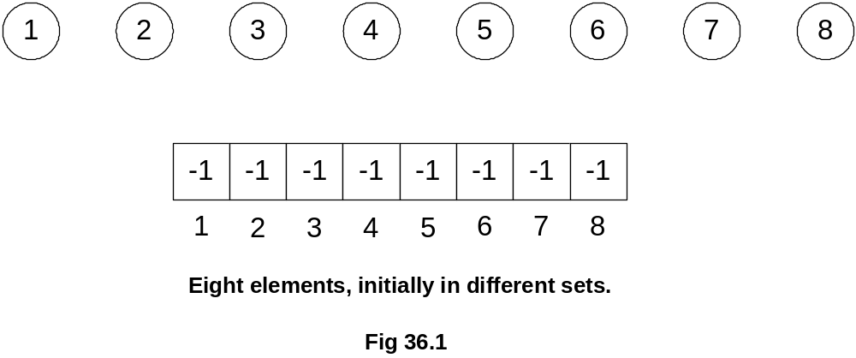

These are eight nodes containing initially –1 in the parent indicating that each tree contains only one node. Let’s unite two trees of 4 and 6. The new tree will be like the one shown in Fig 36.2.
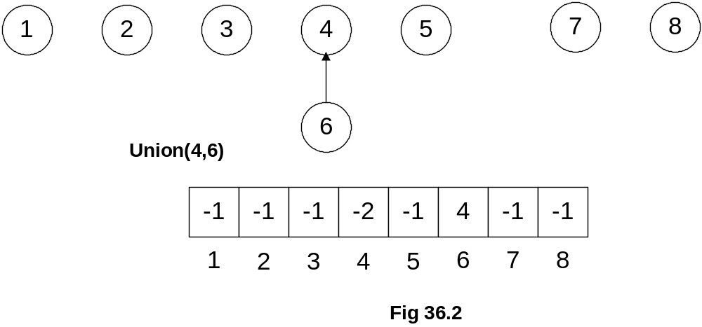

From the figure, you can see the node 6 has come down to node 4. The array also depicts that the parent at position 4 is containing –2. The number of nodes has become 2. The position 6 is set to 4 indicating that parent of 6 is 4. Next, we similarly perform the union operation on nodes 2 and 3.

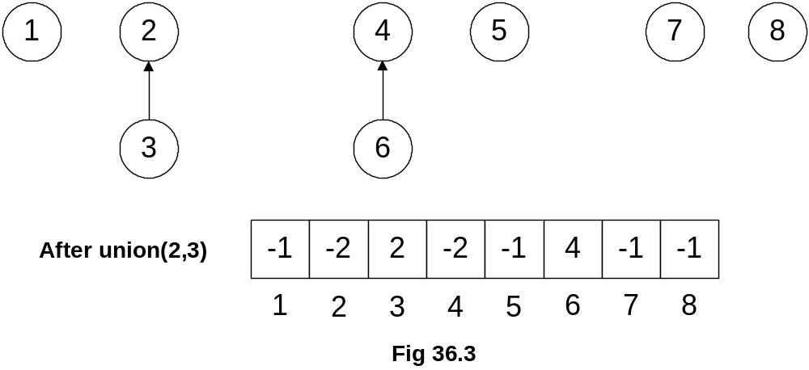

Let’s perform the union operation further and merge the trees 1 and 4.
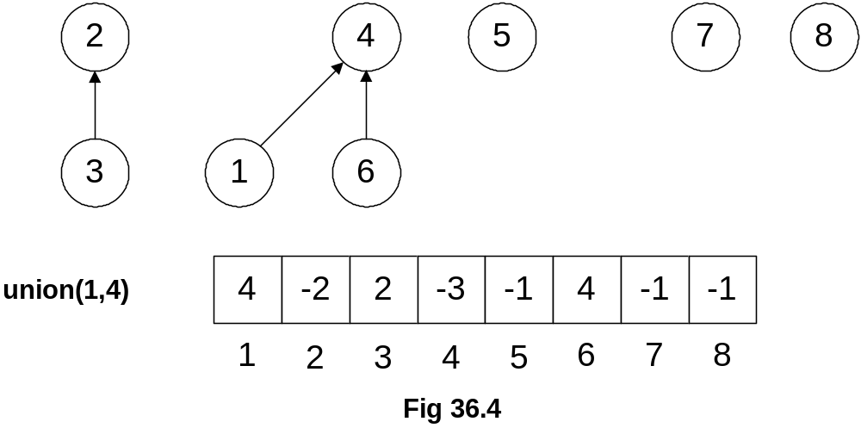

1 was a single node tree (-1 in the array at position 1) and 4 was the root node of the tree with two elements (-2 in the array at position 4) 4 and 6. As the tree with root 4 is greater, therefore, node 1 will become part of it. Previously (when the union was not based on weight), it happened contrary to it with second argument tree becoming the part of the first tree.
In this case, the number of levels in the tree still remains the same (of two levels) as that in the greater tree (with root 4). But we apply our previous logic i.e. the number of levels of the trees would have been increased from two to three after the union. Reducing the tree size was our goal of this approach.

In the next step, we merge the trees of 2 and 4. The size of the tree with root 2 is 2 (actually –2 in the parent array) while the size of the tree with root 4 is 3 (actually –3). So the tree of node 2 will be joined in the tree with root 4.
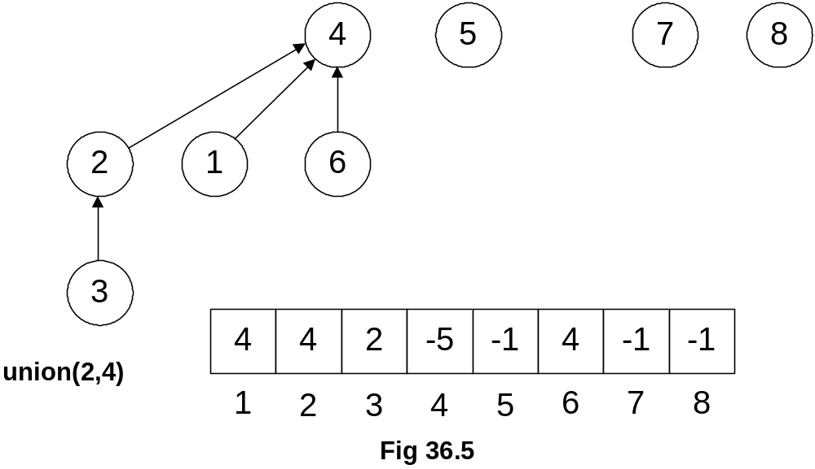
The latest values in the array i.e. at position 4, have been updated to –5 (indicating the size of the tree has reached 5). At position 2, the new value is 4, which indicates that the up node of 2 is 4.
Next, we perform the union(5,4) operation. We know that the size of the tree with node 4 is 5 (-5 in the array) and node 5 is single node tree. As per our rules of union by size, the node 5 will become part of the tree 4.

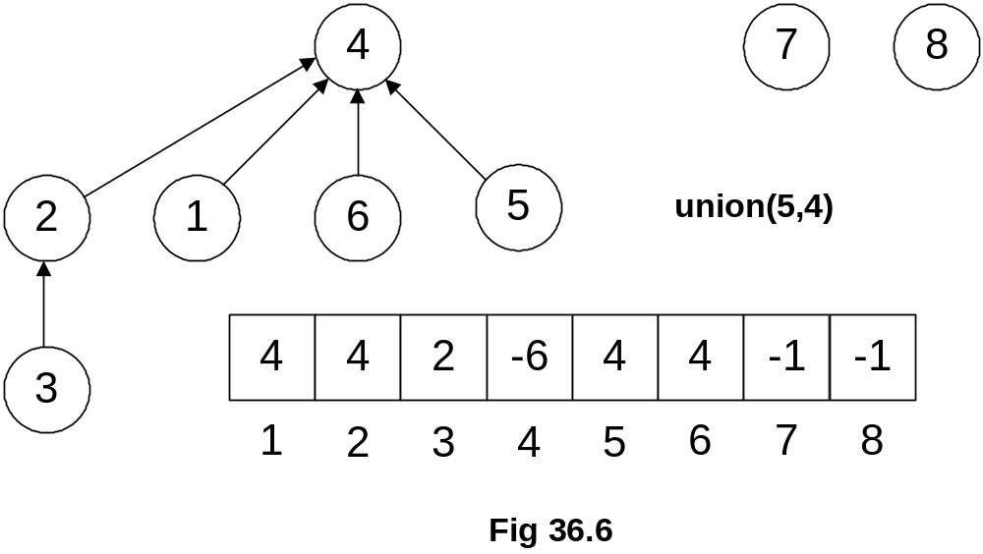

The updates inside the array can be seen as the value at position 4 has been changed to –6 and new value at position 5 is 4. This is the tree obtained after applying the union-by-size approach. Consider, if we had applied the previous method of union, tree’s depth would have been increased more.
It seems that we have achieved our goal of reducing the tree size up to certain extent. Remember, the benefit of reducing the tree height is to increase performance while finding the elements inside the tree.

Analysis of Union by Size

- If unions are done by weight (size), the depth of any element is never greater than log2n.

By following the previous method of union where second tree becomes the part of the first tree, the depth of the tree may extend to N. Here N is the number of nodes in the tree. But if we take size into account and perform union by size, the depth of tree is log2n maximum. Suppose the N is 100,000 i.e.for 100,000 nodes. The previous methods may give us a tree with depth level as 100,000. But on the other hand, log2100000 is approximately 20.Union-by-size gives us a tree of 20 levels of depth maximum. So this is a significant improvement.

Mathematical proof of this improvement is very complex .We are not covering it here but only providing the logic or reasoning in intuitive proof.

Intuitive Proof:
- Initially, every element is at depth zero.
- When its depth increases as a result of a union operation (it’s in the smaller tree), it is placed in a tree that becomes at least twice as large as before (union of two equal size trees).
- How often can each union be carried out? -- log2n times, because after at most log2n unions, the tree will contain all n elements.

Union by Height
- Alternative to union-by-size strategy: maintain heights,
- During union, make a tree with smaller height a subtree of the other.
- Details are left as an exercise.

This is an alternate way of union-by-size that we maintain heights of the trees and join them based on their heights. The tree with smaller height will become part of the one with greater height. This is quite similar with the union-by-size. In order to implement Disjoint Set ADT, any of these solutions can work. Both the techniques i.e. union-by-size and union-by-height are equivalent, although, there are minor differences when analyzed thoroughly.

Now, let’s see what can we do for find operation to make it faster.

Sprucing up Find

- So far we have tried to optimize union.
- Can we optimize find?
- Yes, it can be achieved by using path compression (or compaction).

Considering performance, we can optimize the find method. We have already optimized the trees union operation and now we will see how can optimize the find operation using the path compression.

- During find(i), as we traverse the path from i to root, update parent entries for all these nodes to the root.
- This reduces the heights of all these nodes.
- Pay now, and reap the benefits later!
- Subsequent find may do less work.

To understand the statements above, let’s see the updated code for find below:

find (i)
{
if (parent[i] < 0)
return i;
else
return parent[i] = find(parent[i]);
}

We have modified the code in the body of the find. This implementation is of recursive nature. parent[i] negative means that we have reached the root node. Therefore, we are returning i. If this is not the root node, then find method is being called recursively. We know that parent[i] may be positive or negative. But in this case it will not be negative due to being an index. To understand this recursive call, we elaborate it further with the help of figure. We call the find method with argument 1.

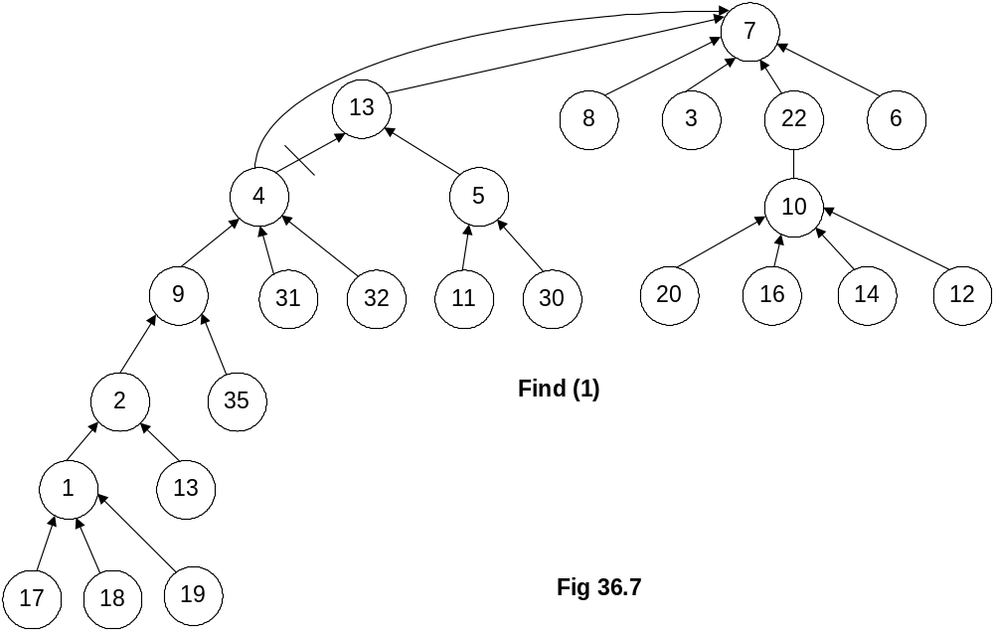

This tree is bigger as compared to the ones in our previous examples, it has been constructed after performing some union operations on trees. Now we have called find method with argument 1. We want to find the set with node 1. By following the previous method of find, we will traverse the tree from 1 to 2, from 2 to 9, 9 to 4, 4 to 13 and finally from 13 to 7, which is the root node, containing the negative number. So the find will return 7.
If we apply recursive mechanism given in the above code, the recursive call will start from find(1). The parent (find(1)) will return 2. The recursive call for 2 will take the control to node 9, then to 4, 13 and then eventually to 7. When find(7) is called, we get the negative number and reach the recursion stopping condition. Afterwards, all the recursive calls, on the stack are executed one by one. The call for 13, find(13) returns 7. find(4) returns 7 because find(parent(4)) returns 7. That is why the link between 4 and 13 has been dropped and a new link is established between 4 and 7 as shown in the Fig 36.7. So the idea is to make the traversal path shorter from a node to the root. The remaining recursive calls will also return 7 as the result of find operation. Therefore, for subsequent calls we establish the links directly from the node to the root.

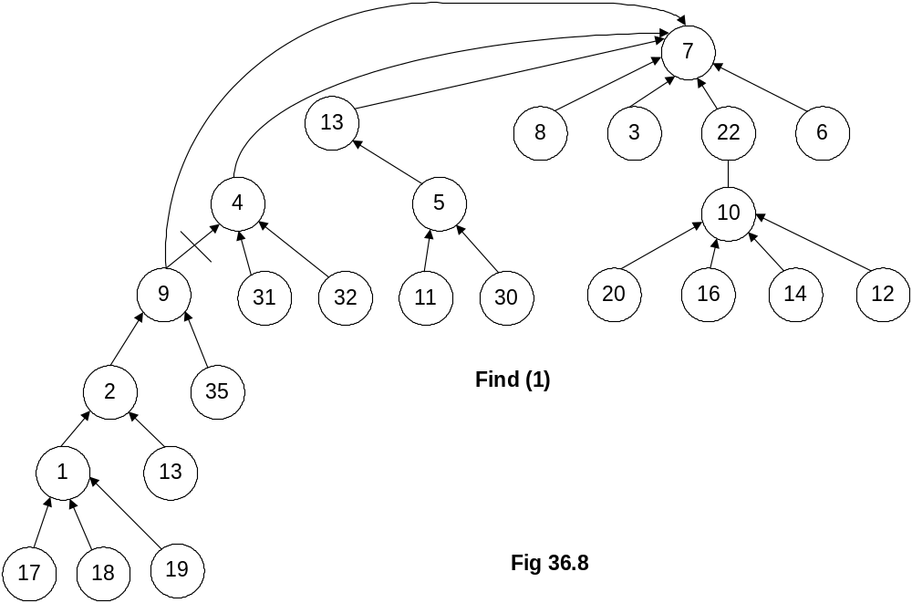

Similarly the node 2 is directly connected to the root node and the interlink between the node 2 and 9 is dropped.

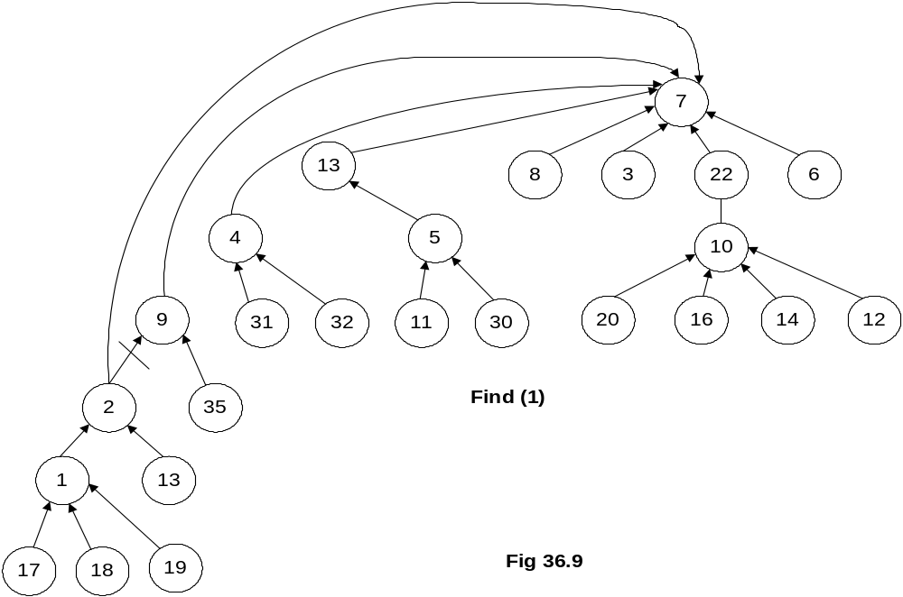

The same will happen with 1.

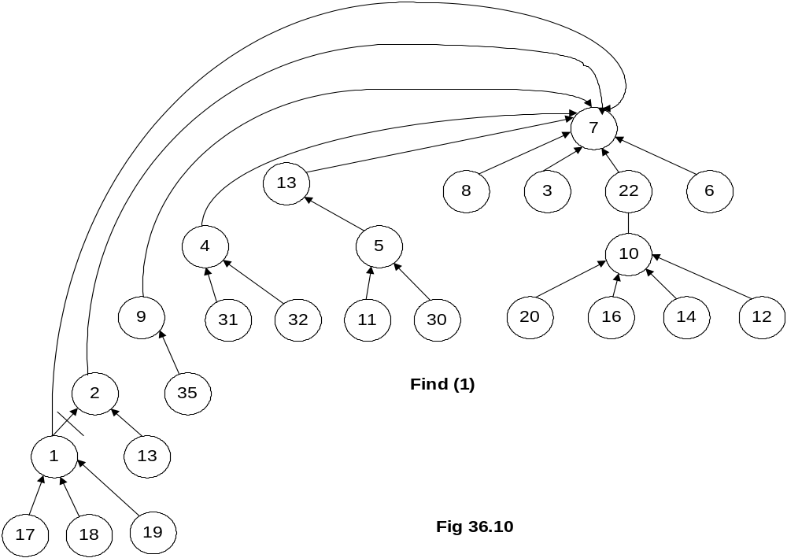

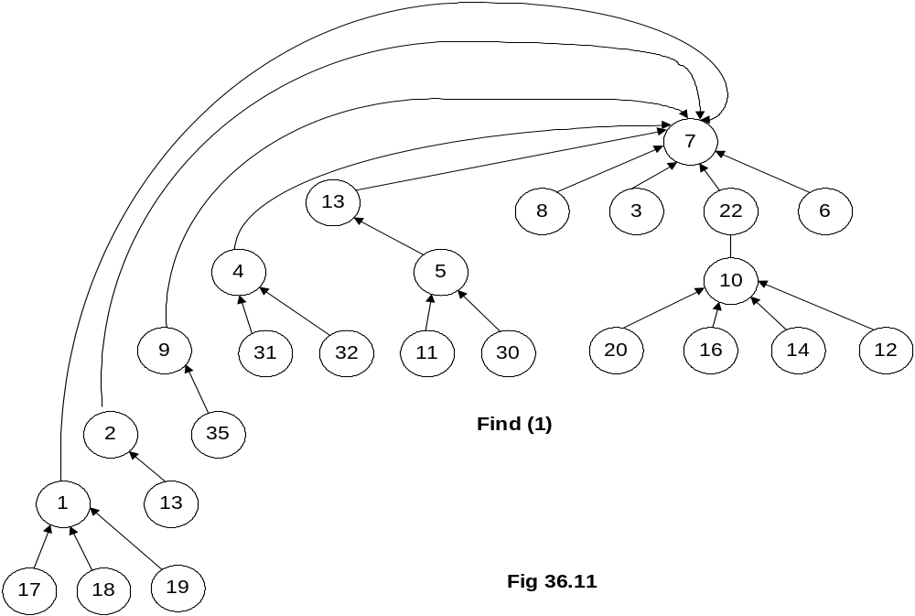

The union operation is based on size or weight but the reducing the in-between links or path compression from nodes to the root is done by the find method. The find method will connect all the nodes on the path to the root node directly.
The path compression is depicted by the following tree:

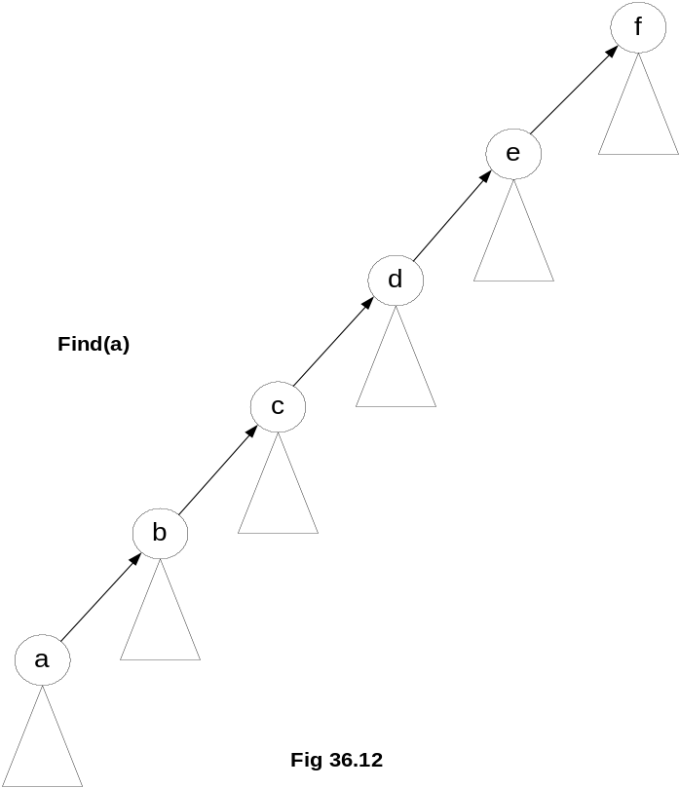

If we have called find(a) then see the path from node a to the root node f. a is connected to root node f through b, c, d and e nodes. Notice that there may be further subtrees below these nodes. After we apply this logic of path compression for find operation, we will have the tree as follows:

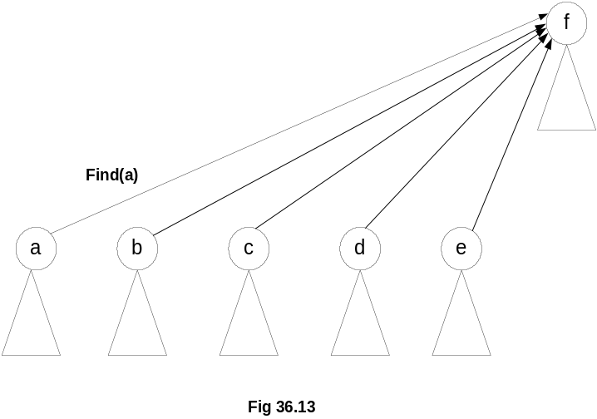
We see, how much is the impact on performance in find by a theorem.

Timing with Optimization
- Theorem: A sequence of m union and find operations, n of which are find operations, can be performed on a disjoint-set forest with union by rank (weight or height) and path compression in worst case time proportional to (mÑ (n)).
- Ñ(n) is the inverse Ackermann’s function which grows extremely slowly. For all practical purposes, Ñ(n) R 4.
- Union-find is essentially proportional to m for a sequence of m operations, linear in m.
There are number of things present in this theorem regarding analysis, which are difficult to cover in this course. We sill study these in course of Algorithm Analysis. At the moment, consider if there are m union operations out of which n are finds. The average time for union-find will be linear in m and it will grow not quadratically or exponentially. union and find operations using this data structure are very efficient regarding both space and time.

